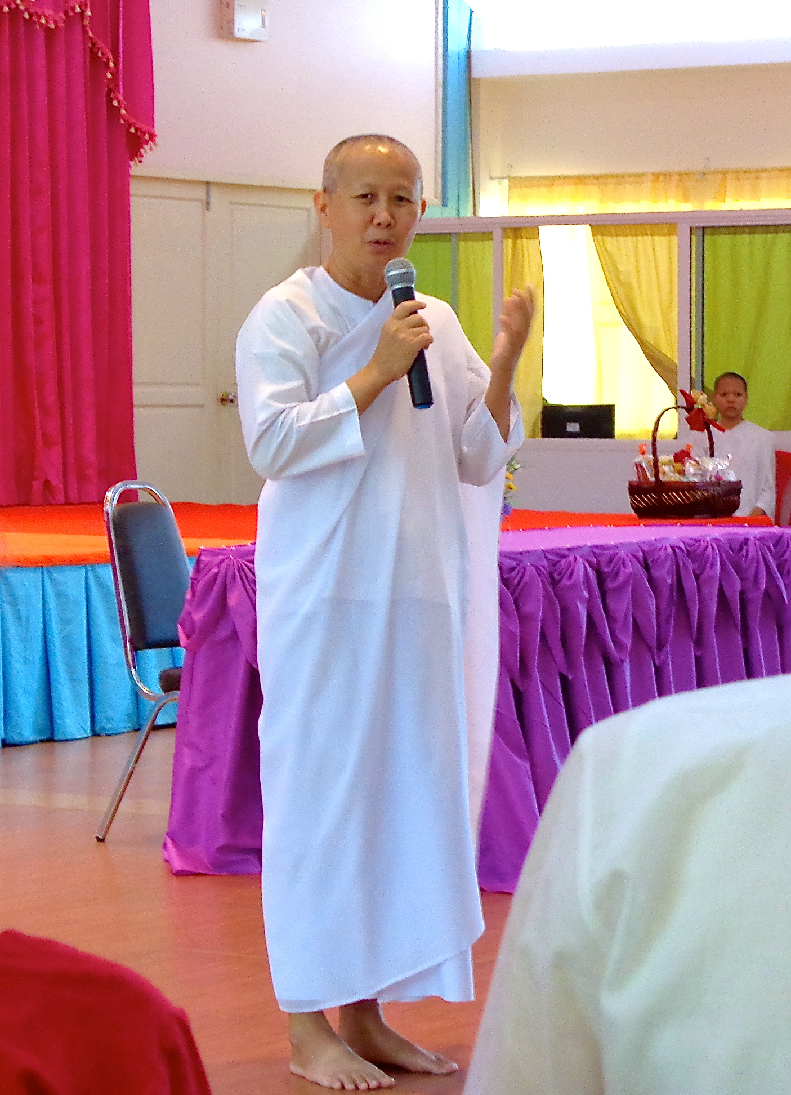
Transforming Lives through Buddhist Education:
Thai Nun Shares
Her Story

BOISE - The Buddha’s teachings are transforming the lives of hundreds of at risk girls in Thailand. At the vanguard of this social service, Dr. Maechee Aunampai Passakchai, is visiting Boise and will speak at 7 p.m. on Saturday, Sept. 9, at the Linh Thuu Temple, at 8813 W. Ardene.

In Thailand, there are many girls and young women who suffer from poverty, abuse, broken families, or who are raised on the streets as orphans. They can become easy prey to opportunists and have little ability by themselves to improve their situation.

In the early 1990’s, their plight became the passion of a small group of Thai Buddhist nuns. These nuns, led by Khun Mae Pradin Kwan-on (former president of Thai Nun’s Institute) and A Yai (Dr. Maechee Aunampai) built the country’s first free Buddhist boarding school.

Since then, the school has expanded markedly under A Yai’s leadership, including a $1 million donation from the Tiger Woods Foundation. The students are earning national awards, are graduating to pursue higher education, and growing to be successful members of society.

A Yai was recently named as one of the "Outstanding Women in Buddhism for 2017” for her untiring and effective work in establishing this program of personal development and academic achievement based on Buddhist principles.

In her naturally loving, witty, and generous way (with an English interpreter), she will share her powerful story about educating girls and street kids in a Buddhist boarding school that teaches Dharma, meditation, a traditional academic curriculum, practical skills as well as ways to manage stress and trauma.

She will highlight how Buddhist teachings are the school’s foundation and support the young women to be happy and enjoy an ethical, productive life. Her visit is made possible by a private sponsor. The talk is free and open to all. No reservations required. For more information, call Tao Oaas at 208-850-8035 weekdays between 2 and 4 p.m.

